Q5. Use Support Vector machine for above problem. And compare the performance of both. Explain the input parameters you provided for the classifier. (10M)

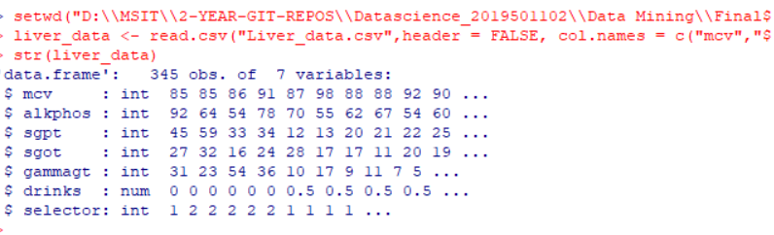

Setting directory, and reading csv file and giving names for columns.

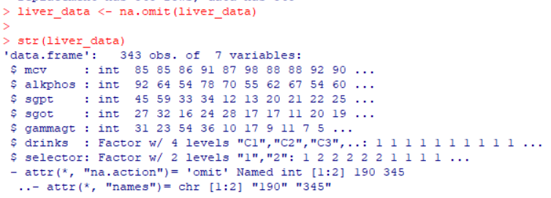

Removing the missing values from the dataset.

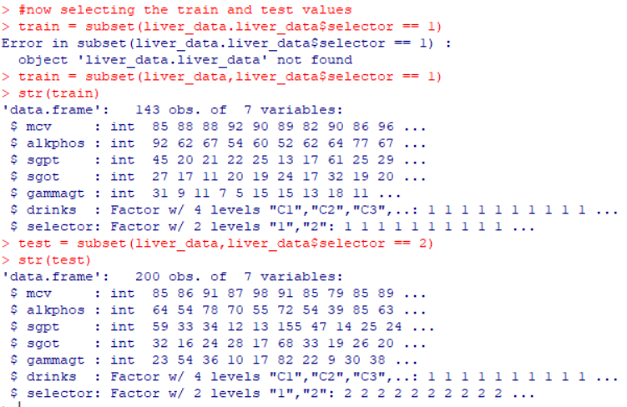

1 means train data, 2 means test data.

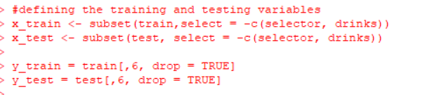

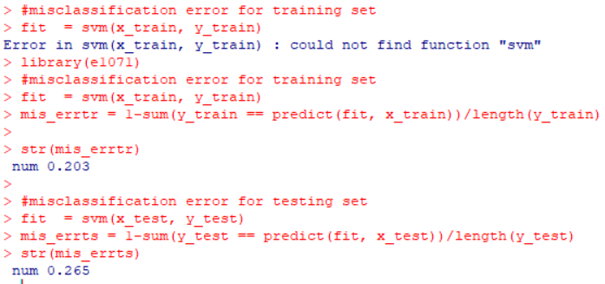

The misclassification errors for both training set and test set are 0.203 and 0.265.

Comparing both knn and svm, misclassification error for knn was less than svm, so it is better to use KNN for classification.